**M**ind, **B**rain, and **M**odels 2022

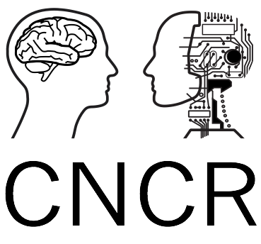

Modelling First-Order Tactile Neurons with TouchSim_v1

In this lab we will use TouchSim model (Saal et al., 2017) of first-order tactile neurons to run a simulated experiment on tactile perception. The tool is available here: https://github.com/BensmaiaLab/touchSim

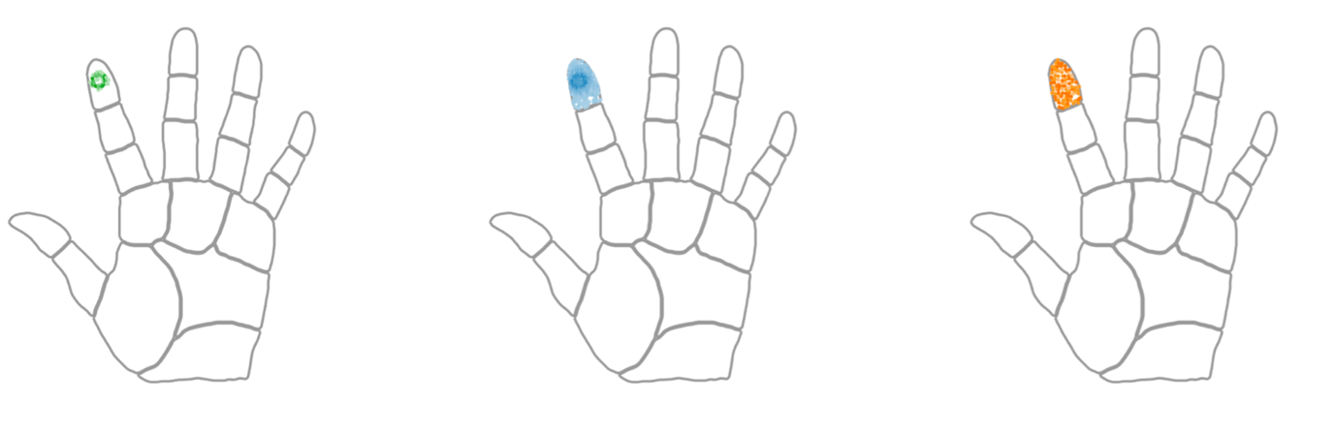

This workshop is divided in three small parts. The main task is for you to come up with a simple research question and run a virtual experiment to test it. Choose a single stimulus parameter to manipulate and run simulation to assess how the manipulation affects the firing rate of the virtual neurons. As an example, we will look at how different vibration frequencies of a single pin affect the response of the three classes of simulated neurons.

You will be provided a script with examples that we will go through in the workshop. The script is supposed to inspire you by giving an example, but it is not supposed to be taken verbatim or copied. There are also few things missing...

**TASKS 1 – Create and plot a RANDOMLY DISTRIBUTED population of afferent for each type (within the same area of skin)**

1. Create an ‘empty hand’ object with the function AfferentPopulation().
2. Use the function meshgrid to create a grid of coordinates for each afferent type. The grid will be linearly spaced. Then, modify the grid to shift each coordinate slightly around their original point. The shift should be a random value between 0.1 mm and 0.5 mm.
3. Plot the virtual afferents and comment in which way this differs from real afferent distribution. (b)

**TASKS 2 – Create the stimuli for your virtual experiment**

1. Choose a property of the stimulus to test how the model responds. Describe how do you think it will affect the response given by the simulation by making a reference to the lecture and reading material. The modification could be along any of the dimensional properties of the stimulus, e.g. shape, orientation, etc. (a)
2. Use one of the functions to create two versions of the virtual stimulus (e.g. stim_sine) by applying the manipulation you are going to test in the virtual experiment.
3. Visualize the key property of the two virtual stimuli that you modify and comment on what assumptions you made to create such stimulus. I.e., how it is different from what you can achieve in an experiment with a human. (b)

**TASK 3 – Simulate the response, evaluate the outcome and report the results**

1. Use the obj.response function to simulate the activity of the three afferent types in response to the two stimuli.
2. Visualise the responses for each afferent type and compare them for the two stimuli. (c)
3. Discuss whether you obtained what you expected to obtain and what you can infer about either the model or tactile sensory system. (d)

You should write the report to highlight the hypothesis, procedure you followed and your findings, by dividing it in sections: (a) Intro/Research Question; (b) Methods; (c) Results; (d) Discussion/Conclusion. Submit also your script and any function you wrote or modify from touchsim (not the whole package).

**Assessment criteria**

1. Intro/Research Question - 10%
2. Methods - 30%
3. Results - 40%
4. Conclusion - 20%